How to create the instance in EC2:-

Go to AWS console & open the EC2 Dashboard

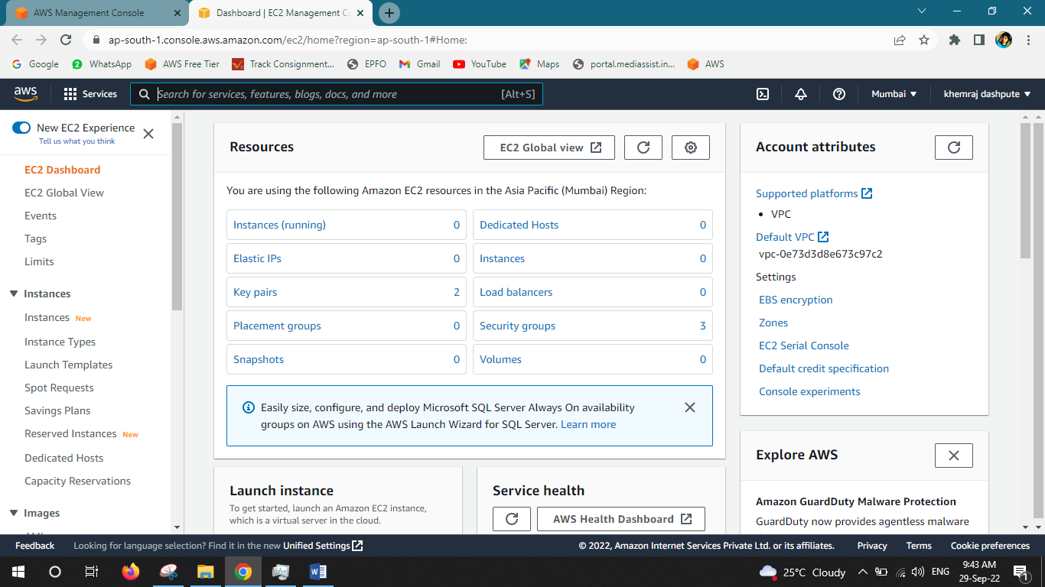



Go to Instance & launch Instance

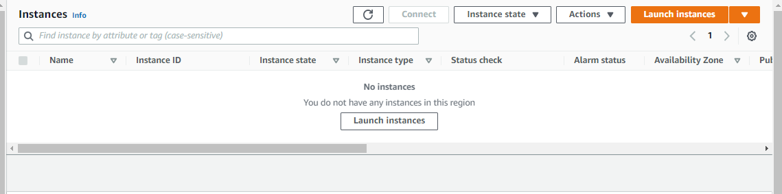



Select the opt old experience for better understand

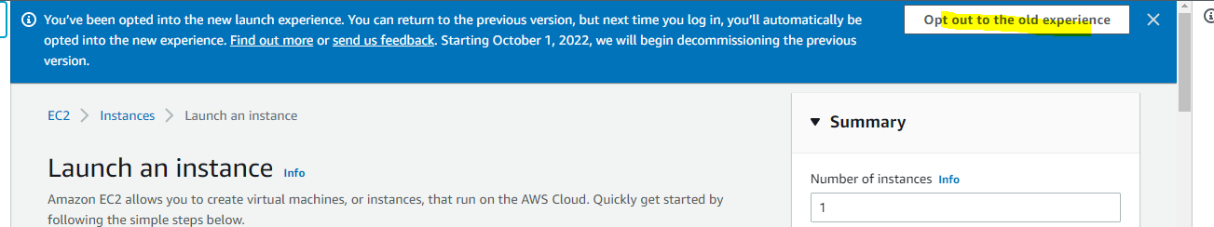

Now we can see the instance Amazon Machine Image (AMI)

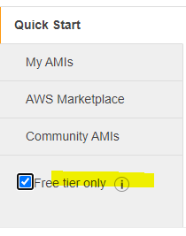

We are doing the free practical so we can select the free tier image only

Then we can see the free images & select the free image for practical.

We can select the ***Windows server 2022 Base image- 64bit***

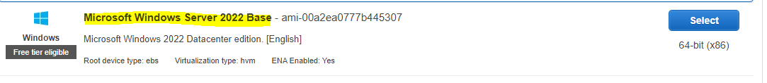

Free tier should be the t2micro & click on Next: Configuration Instance

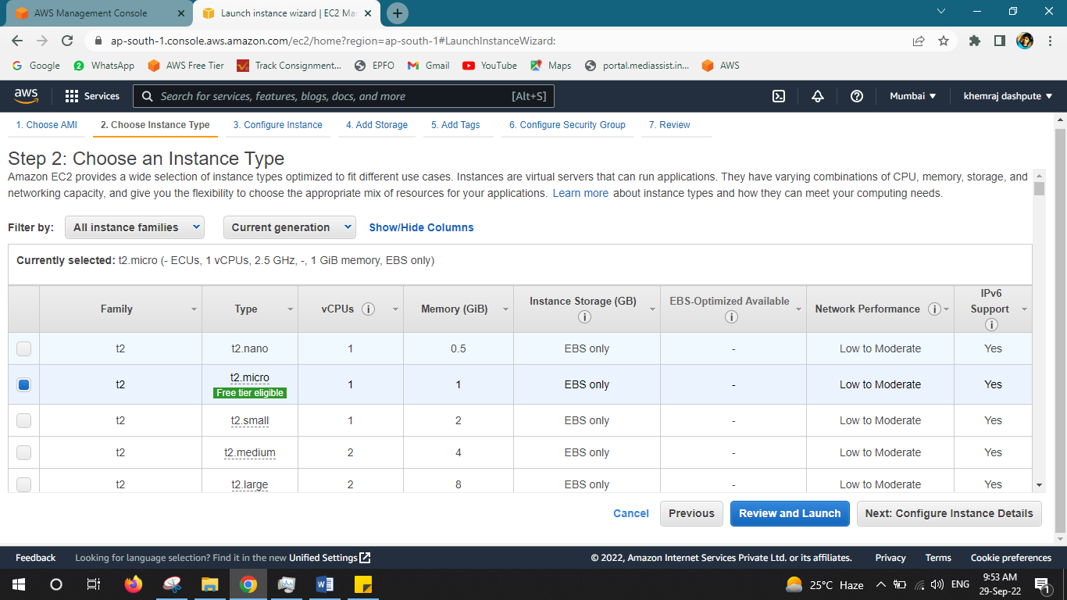



Now in Configuration Instance Details

1. Number of instance – 1
2. Auto assign public IP – Enable

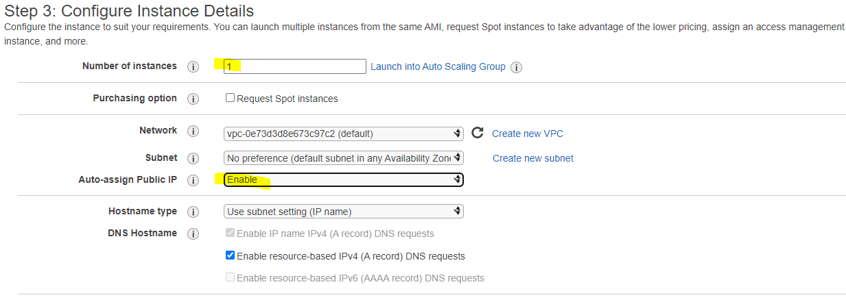

And the

1. tenancy model – Shared –Run shared hardware- go to Next-add Storage

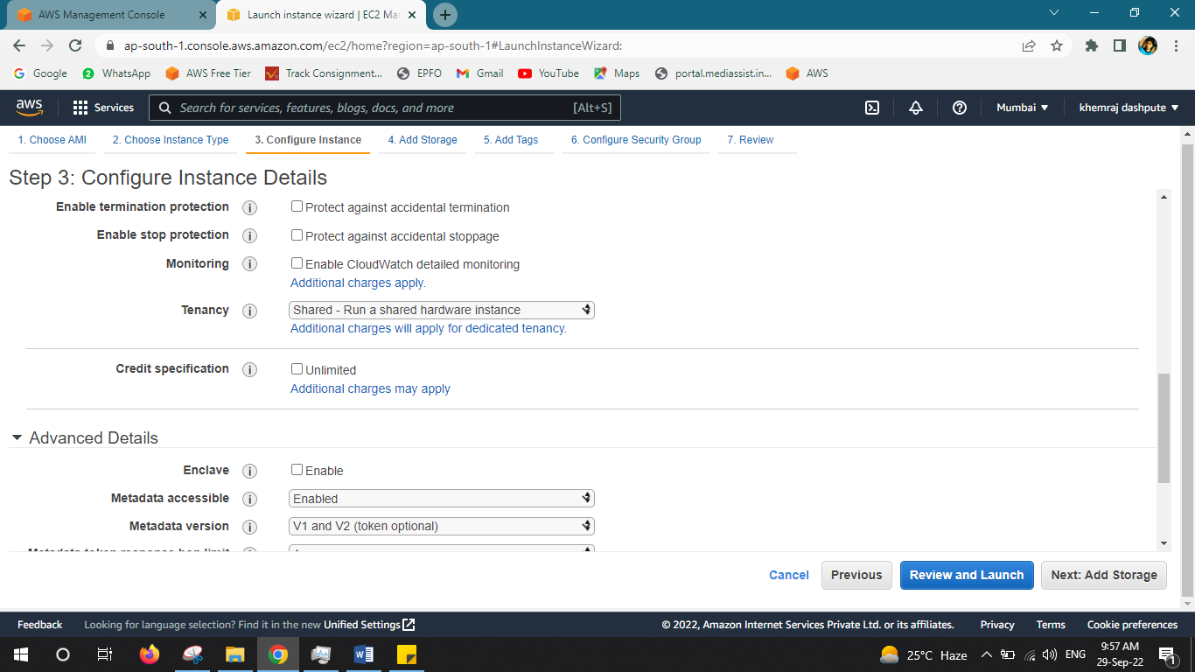



In Storage –we can see the details about storage

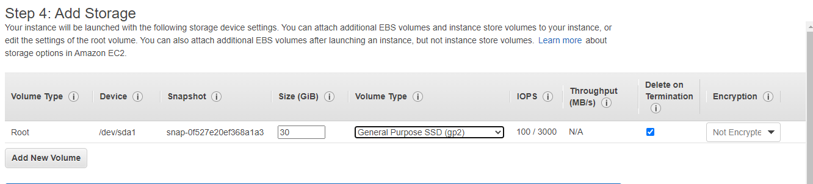

Go to next: Add tags – Click the add tags and name & give the name

I give the name - *Windows-test-01*- Next Configuration Security Group

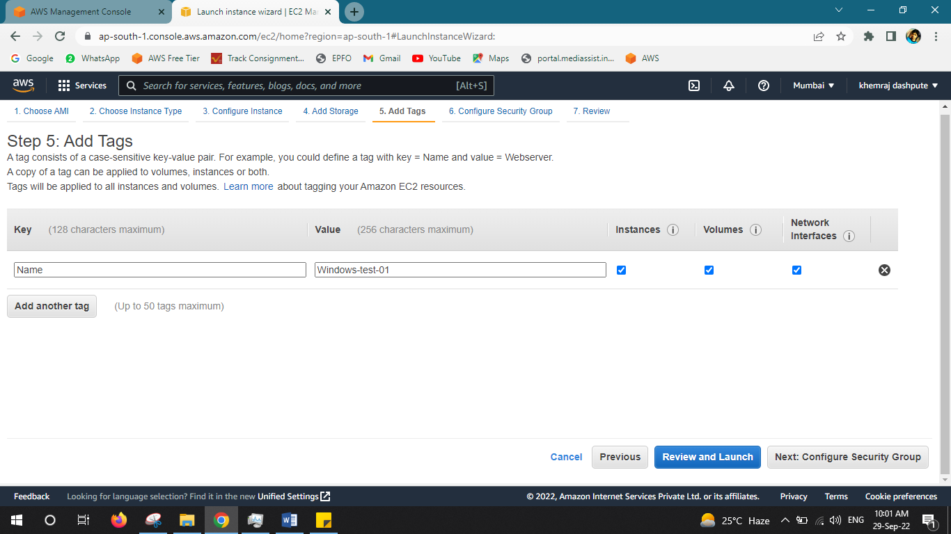



Create the new security group – New

Group name - open-rdp-test-01

Make sure in source tab –select the **Anywhere**

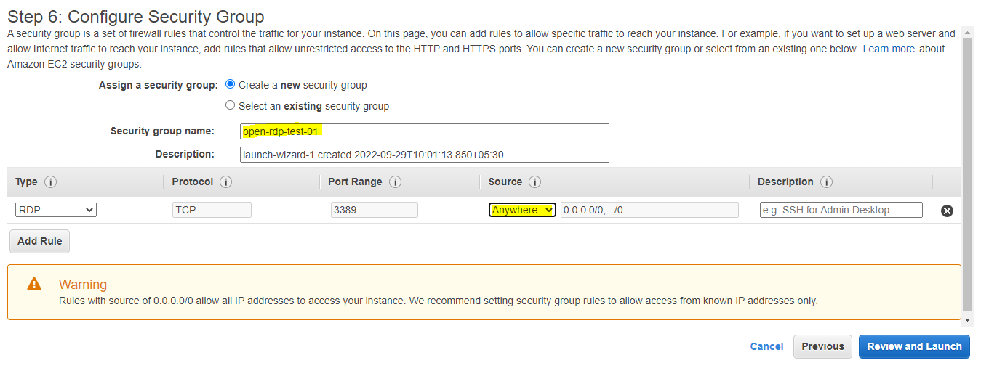

**Review & Launch**

-When you select the Anywhere –you will receive the below error – for access instance from anywhere (internet)- Its access from internet

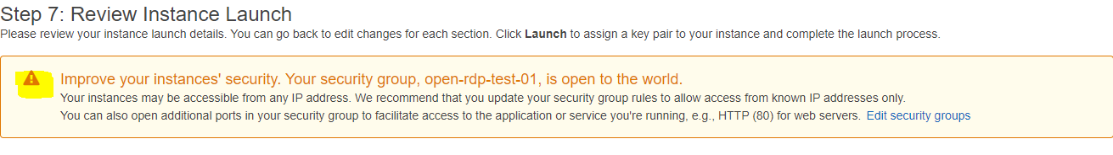

In Review tab you can see the details which you have select for creating instance & you can edit here if you need any change for finalization.

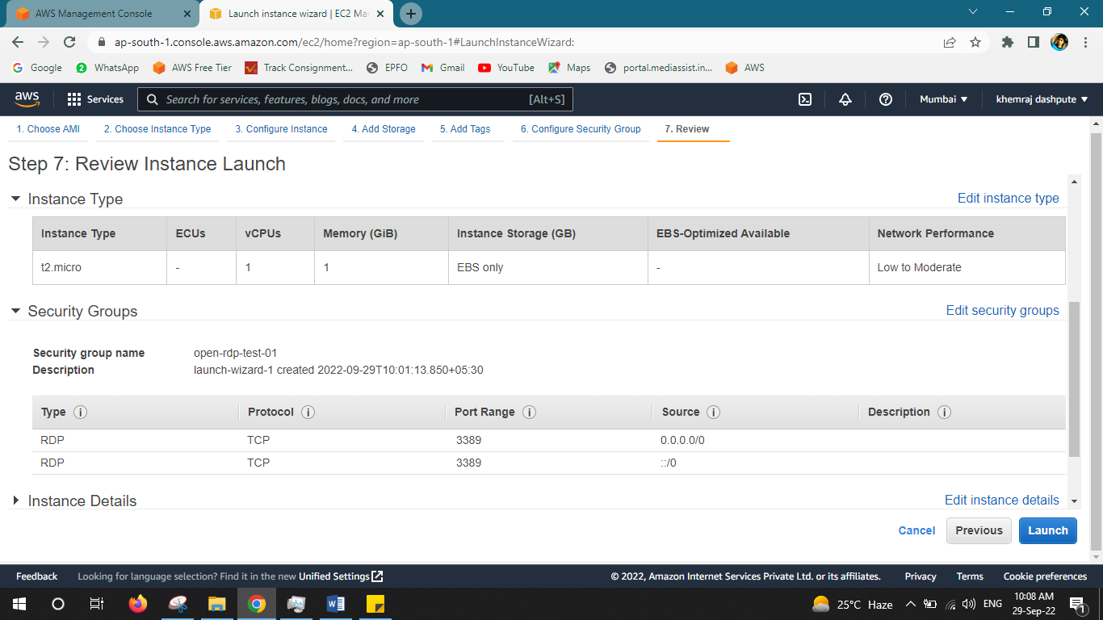



We never want changes so go to – ***Launch***

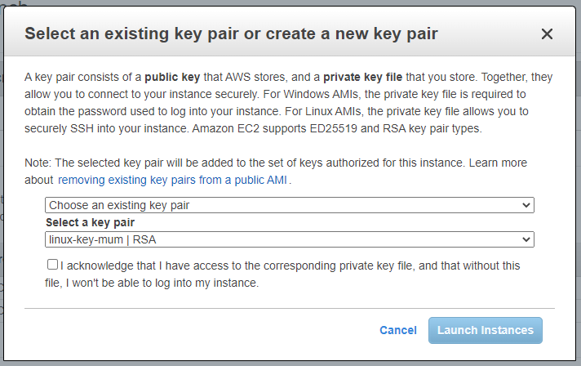When you launch the Instance –its gives you message to create the public & private key

Chose the new key & create for us.



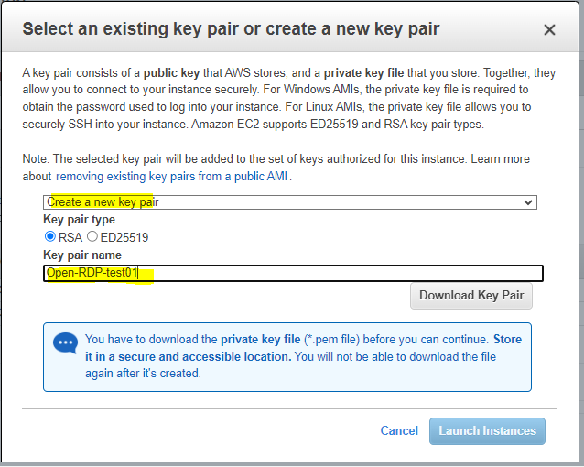Create a new key pair

Key name –

*Open-RDP-test-01*

Download Key Pair

For Security purpose we can save the key in safe place – Launch the Instance

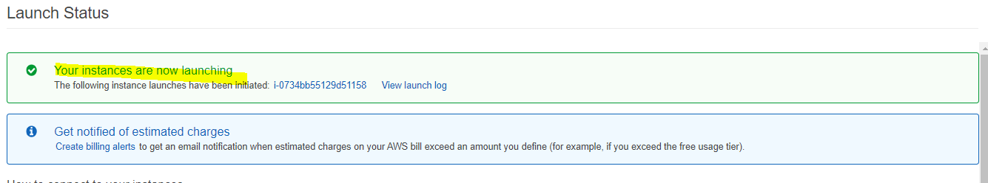

You will see this message –means the Instance is ready for launch – View Instance

In Instance we can see the instance ready

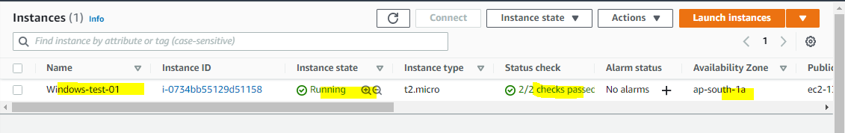

Go to connect tab – RDP client – Get password

We need the key file for password generate

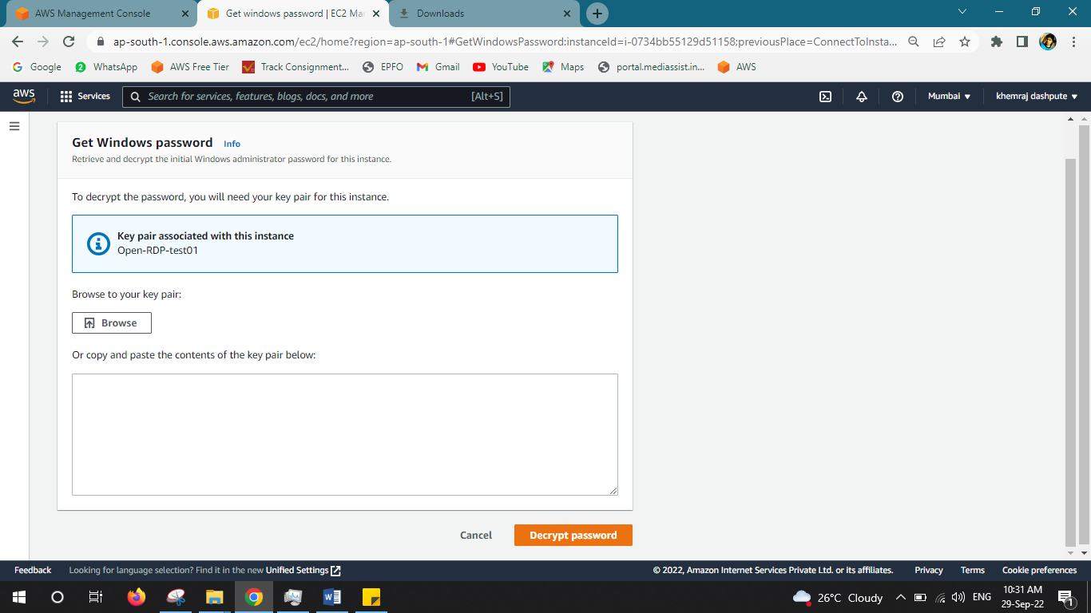



Browse the file & Decrypt the password – I will get the password

Save the password in safe place for RDP instance

& now I am trying to RDP or I can download the RDP file & take the RDP.

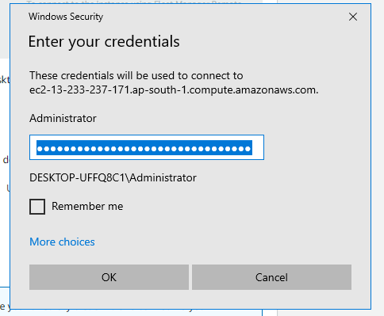

My RDP works & I can login in my instance now –

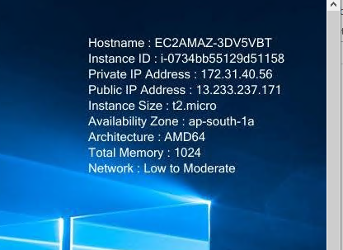In the left side of instance, we can see the details about machine & others...

Host name:

Instance ID:

Private IP address:

Public IP Address:

Instance Size:

Architecture:

Memory:

We can try the same process for Linux machine as well –

I have created the *Red hat machine* & it’s initializing now –

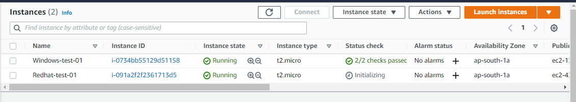



After initiate the Red hat machine you need putty applications for remote in windows environment

I have downloaded putty, puttygen & pagent for access the Linux machine.

* 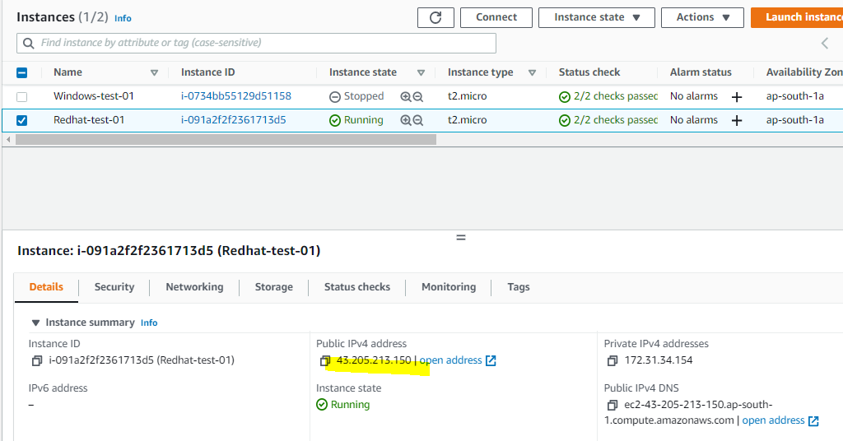 Now go to Red hat instance & copy the public IP from the red hat



Now I go to putty application & open the putty put the host name: 43.205.213.150 port 22

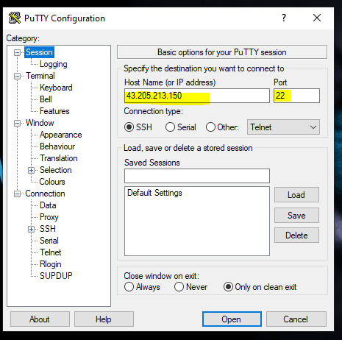

Now in putty go to connection tab = SSH= Auth & browse the key & put it there .ppk file



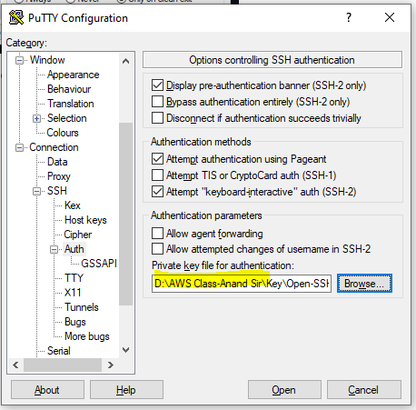

After that you will see the below window – you can just click accept

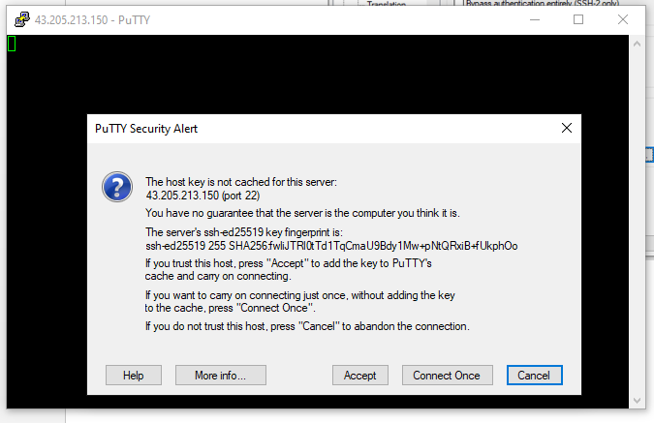



After accept the login it asked for user name – *ec2-user*

You can find the user name in Red hat Instance – Connect – EC2 instance connection

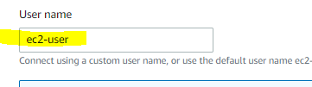

Login now – not working due to I don’t have ssh client – now we need to convert the file

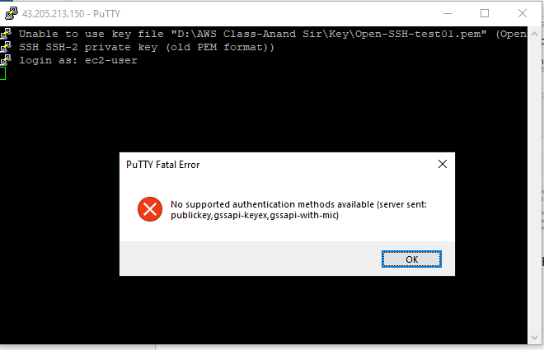

Now we open the puttygen for convert the file

Go to puttygen- Load –give the file path & upload

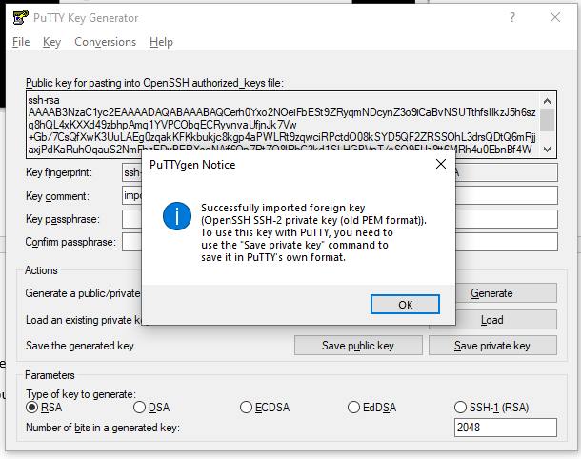

After upload the file it shows you puttygen successfully imported foreign key.

Now click okey

Save the file in key location as ***.ppk

Now go to putty application & try to open the red hat machine

Give the host name: - 43.205.213.150 port 22

Go to Connection – Auth –give the .ppk file now

User able to login Red hat machine with putty console

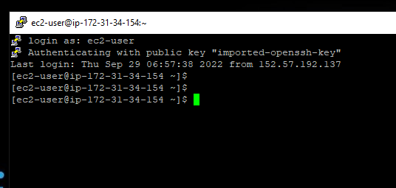

*We have lauch the Windows & Linux intsnce from EC2*

Now We can test the 2by2 instacne check –

We can try if disable the NIC card in windows machine ,How to fix that –

I have one machine & suddein the 2by2 test shows failed

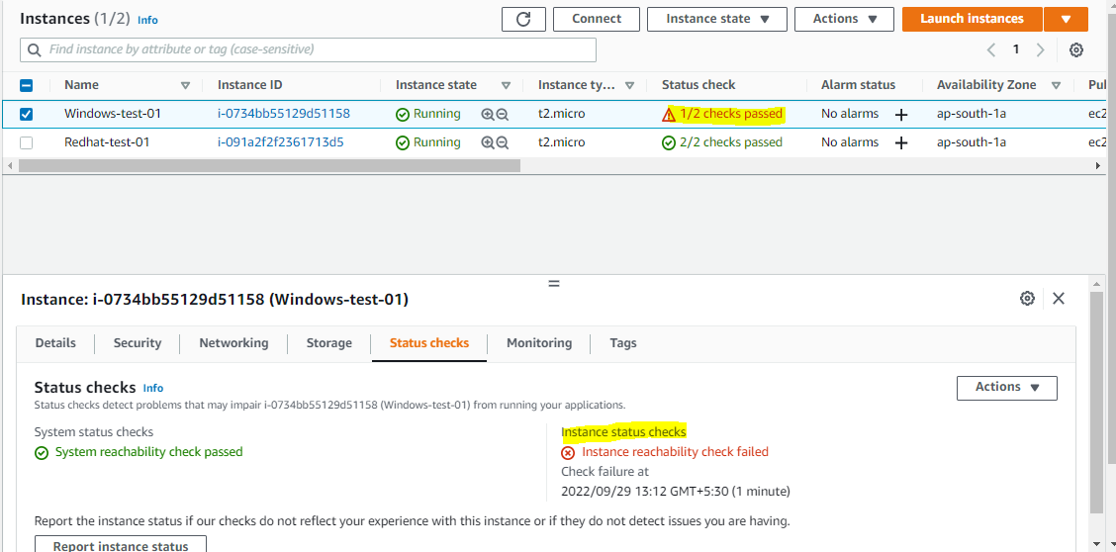

Now we can troubleshoot & find as there is 2nd check failed – Instacne reachability check faild

Troubleshooting –

* We have restart the Instance but no luck
* We have Stop the session & Start the fresh but no luck
* We have force stop & Start but still nic disable
* Force reboot but no luck –NIC still disable

Now we can troublshoot & add a new NIC card so the instacne will up

We can go to EC2 console & go to Network & Security – Network Instacne

Create a new Network Interface –

* Description – NIC-02
* Subnet – ap-south-1a(which is my subnet in windows-test-01)

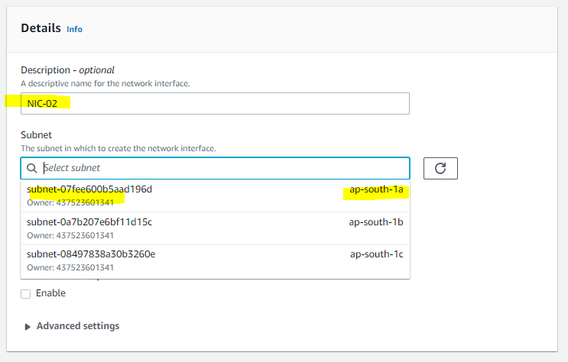

Go to Scurity group option & selcet the right group – *open-rdp-test-01*

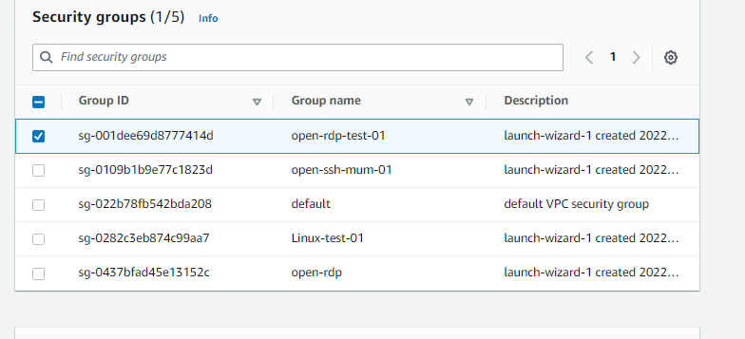

We don’t need the tag – so Create the network interface –

Give the name as *– 2nd NIC Card*

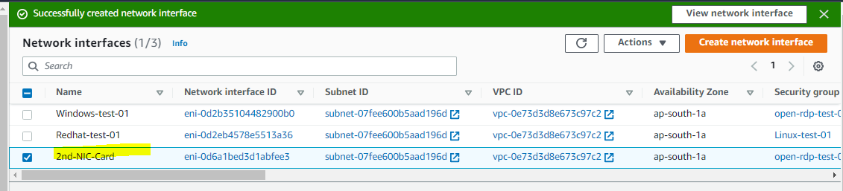

Now NIC has been created but we need to attache

Select the 2nd NIC card – Attach with correct Instacne – *Windows-test-01*

Attach

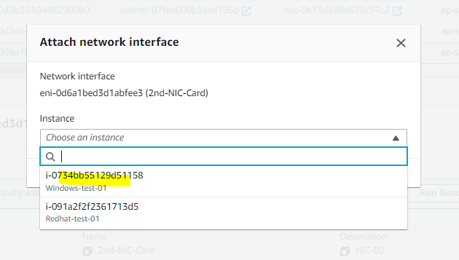

Now we can go to Instance & see there is 2 IP shows in Private IP –means IP has been attached

Now the case you can up the instacne with 2nd NIC card

In this case you can take remote – *172.31.32.227* & enable the 1st NIC card.

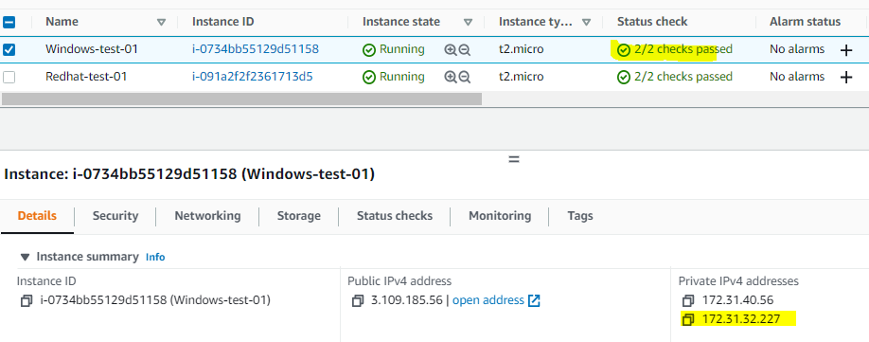

but if you allocate the Elastic IP & configure the IP instacne then we follow the belwo steps –

Go to Elastic IP – Allocate the Elastic IP –**Allocate**

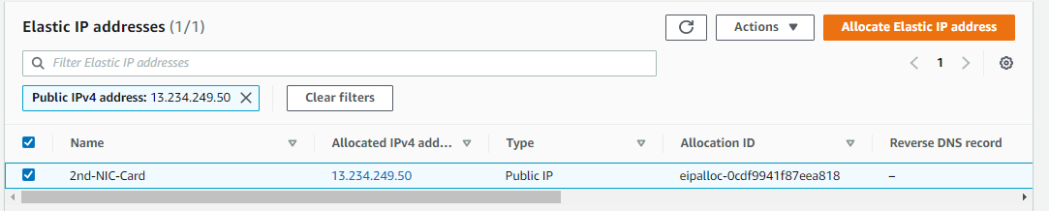



Now assosiate the Elastic IP –

Go to Action – Associate the Elastic IP address

* Resource type – Network
* Network Interface- 2nd-NIC-Card

Reassociation

* Allow the Elastic IP-Associte

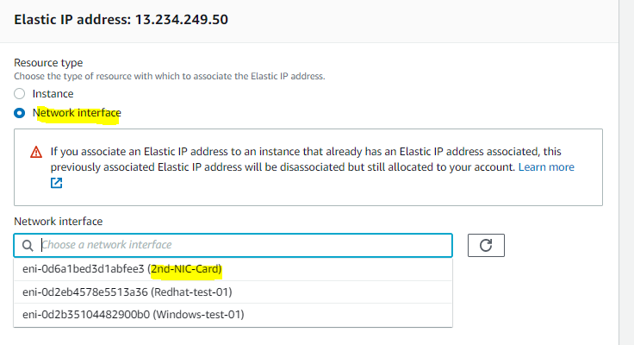

Now go to intance & open the *Windows-test-01* check in networking tab under the networking tab

Elastic IP will shows with us-

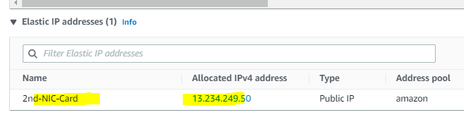

Now we can try remote the mstsc with Elastic IP 13.234.249.50



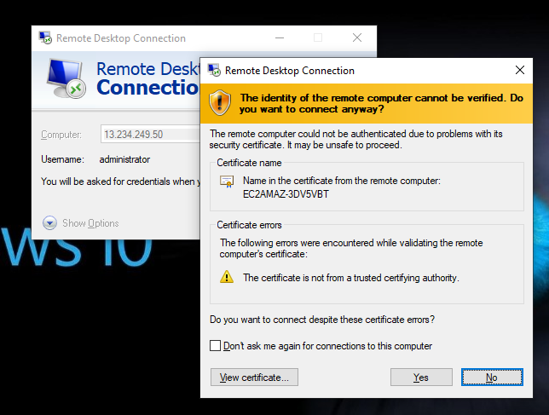We got the remote sesssion & we can connect with system-

Now we can take remote & login the Instacne

We can see the network has been disable & now we can enable that –

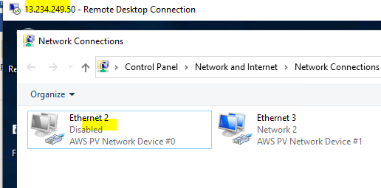

Both NIC shows Enable in cmd –

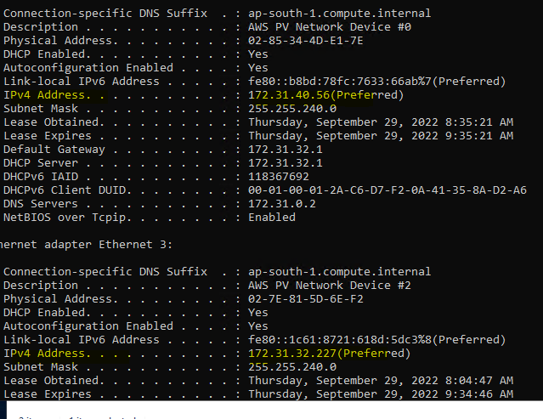

Now we have enable the Instance NIC (Default)

Now we can disable the Elastc IP & remove the NIC card from Instacne

Go to Elastic IP – Action – Dissassciate Elastic IP

Selcet the Elastic IP –Action- Release the Elatic IP address

Remove the NIC card – Go to – 2nd-NIC-Card- Action –Detach –Force Detach(Enable)- Detach

Select the 2nd-NIC-Card- Action –Delete

After Delete the *2nd NIC card –*We have login the Instance & now only 1 NIC are visible (Default)

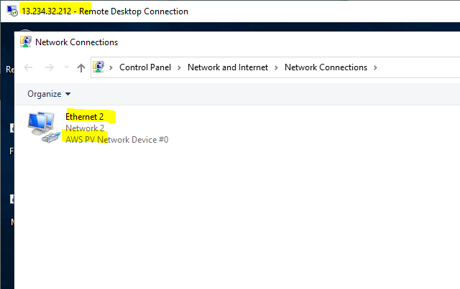

**Important Notes:-**

* Private IP address never change till we can terminate the Instance.
* Public IP addresss has been change ,if we stop – start the Instance.
* Public Static IP –we called as Elastic IP
* AWS will charge if you are not used the Elastic IP just for keeping self with you.

**More Imp:-**

Question : How many elastic IPs can I have in AWS?

Answer :- All AWS accounts are limited to **five Elastic IP addresses per Region**.